

[DockerFile and Docker-Compose]



**Docker Setup for AppFlowy**

## Introduction

This document outlines the steps to set up a Docker environment for the AppFlowy project. The goal is to containerize the AppFlowy application and its dependencies using Docker and Docker Compose.

Step 1: Clone the AppFlowy Repository

Clone the AppFlowy repository to your local machine.

Step 2: Create Dockerfile

Check if there is already a Dockerfile in the repository. If not, create one. For example, create a Dockerfile in the project root with the following content:

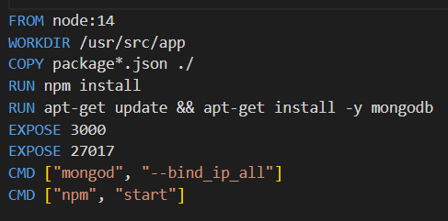

Step 3: Create Docker Compose File

Create a docker-compose.yml file in the project root:

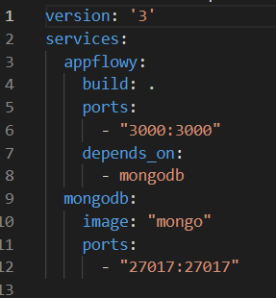

Step 4: Continuous Integration

Consider setting up a continuous integration (CI) pipeline to automatically build and test the Docker images whenever changes are pushed to the repository.

Now, anyone can clone the repository and use Docker Compose to deploy the entire application stack with a single command: docker-compose up